Preparation of papers in JEAS template - Subject (Paste as keep text only here)

Author 1 (Paste as keep text only here)
Author Affiliation, and info.
Author 2 (Paste as keep text only here)
Author Affiliation, and info.
Corresponding author email only
Author 3 (Paste as keep text only here)
Author Affiliation, and info.

ABSTRACT
The abstract should appear at the beginning of your paper. It should be one paragraph long (not an introduction) and complete in itself (no reference numbers). It should indicate subjects dealt with in the paper and state the objectives of the investigation. Newly observed facts and conclusions of the experiment or argument discussed in the paper must be stated in summary form; readers should not have to read the paper to understand the abstract. The abstract should be Italic with Times New Roman, 11-point size
Key Words: Times New Roman, 11-point size, Times New Roman, 11-point size, Times New Roman, 11-point size

Publication by JEAS
Your manuscript cannot be published by JEAS if:
1) It has been published previously or
2) The work contains copyright-infringing material or
3) An appropriate copyright statement has not yet been selected.

Introduction
This document is a template for Microsoft Word 2010 or later. If you are reading a hard-copy or .pdf version of this document, download the JEAS Meeting Papers Template from the Meeting Paper Author page at our website or from the Technical Presenter Resources page for the appropriate JEAS forum, and use it to prepare your manuscript. Authors using Microsoft Word will first need to save the JEAS Meeting Papers Template.doc or docx file in the “Templates” directory of their hard drive.

Document Text
The default font for JEAS papers is Times New Roman, 11-point size. In the electronic template, use the “Text” or “Normal” style from the pull-down menu to format all primary text for your manuscript. The first line of every paragraph should be indented, and all lines should be single-spaced. Default margins are 1” on all sides. In the electronic version of this template, all margins and other formatting is preset. There should be no additional lines between paragraphs.

Images, Figures, and Tables
All artwork, captions, figures, graphs, and tables will be reproduced exactly as submitted. Be sure to position any figures, tables, graphs, or pictures as you want them printed. JEAS will not be responsible for incorporating your figures, tables, etc. (Company logos and identification numbers are not permitted on your illustrations.)
Do not insert your tables and figures in text boxes. Figures should have no background, borders, or outlines. In the electronic template, use the “Figure” style from the pull-down formatting menu to type caption text. You may also insert the caption by going to the References menu and choosing Insert Caption. Make sure the label is “Fig.,” and type your caption text in the box provided. Captions are bold with a single tab (no hyphen or other character) between the figure number and figure description.
Table font is Times New Roman, 8-point size
Statistics |  |  |  | Variable
Maximum | Minimum | Standard deviation | Average
5/00 | 1.00 | 87/0 | 90/3 | Innovation
5/00 | 1.00 | 81/0 | 92/3 | Quality
5/00 | 1.00 | 99/0 | 88/3 | Customer Relationships
5/00 | 1.00 | 79/0 | 80/3 | Management capabilities
5/00 | 1.00 | 91/0 | 76/2 | Technology
5/00 | 1.00 | 80/0 | 04/3 | Brand values

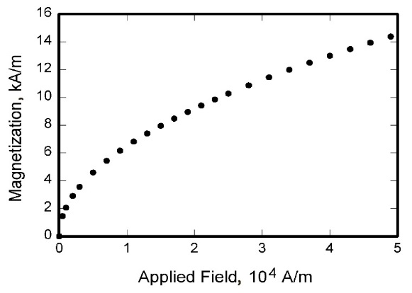
Fig. 1 Magnetization as a function of applied fields.

Equations, Numbers, Symbols, and Abbreviations
Equations are centered and numbered consecutively, with equation numbers in parentheses flush right, as in Eq. (1). Insert a blank line above and below the equation. First use the equation editor to create the equation. If you are using Microsoft Word, use either the Microsoft Equation Editor or the MathType add-on (http://www.mathtype.com) for equations in your paper, use the function (Insert>Object>Create New>Microsoft Equation or MathType Equation) to insert it into the document. Please note that “Float over text” should not be selected. To insert the equation into the document:
          - Select the “Equation” style from the pull-down formatting menu and hit “tab” once.
          - Insert the equation, hit “tab” again,
          - Enter the equation number in parentheses.
A sample equation is included here, formatted using the preceding instructions. To make your equation more compact, you can use the solidus (/), the exp function, or appropriate exponents. Use parentheses to avoid ambiguities in denominators.
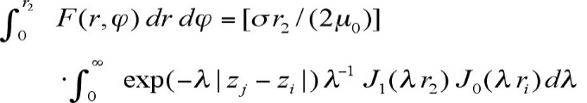 (1)
Be sure that the symbols in your equation are defined before the equation appears, or immediately following. Italicize symbols (T might refer to temperature, but T is the unit tesla). Refer to “Eq. (1),” not “(1)” or “equation (1)” except at the beginning of a sentence: “Equation (1) is…” Equations can be labeled other than “Eq.” should they represent inequalities, matrices, or boundary conditions. If what is represented is really more than one equation, the abbreviation “Eqs.” can be used.
Define abbreviations and acronyms the first time they are used in the text, even after they have already been defined in the abstract. Very common abbreviations such as JEAS, SI, ac, and dc do not have to be defined. Abbreviations that incorporate periods should not have spaces: write “P.R.,” not “P. R.” Delete periods between initials if the abbreviation has three or more initials; e.g., U.N. but ESA. Do not use abbreviations in the title unless they are unavoidable (for instance, “JEAS” in the title of this article).

General Grammar and Preferred Usage
Use only one space after periods or colons. Hyphenate complex modifiers: “zero-field-cooled magnetization.” Avoid dangling participles, such as, “Using Eq. (1), the potential was calculated.” [It is not clear who or what used Eq. (1).] Write instead “The potential was calculated using Eq. (1),” or “Using Eq. (1), we calculated the potential.”
Use a zero before decimal points: “0.25,” not “.25.” Use “cm²,” not “cc.” Indicate sample dimensions as “0.1 cm x 0.2 cm,” not “0.1 x 0.2 cm².” The preferred abbreviation for “seconds” is “s,” not “sec.” Do not mix complete spellings and abbreviations of units: use “Wb/m²” or “webers per square meter,” not “webers/m².” When expressing a range of values, write “7 to 9” or “7-9,” not “7~9.”
A parenthetical statement at the end of a sentence is punctuated outside of the closing parenthesis (like this). (A parenthetical sentence is punctuated within parenthesis.) In American English, periods and commas are placed within quotation marks, like “this period.” Other punctuation is “outside”! Avoid contractions; for example, write “do not” instead of “don’t.” The serial comma is preferred: “A, B, and C” instead of “A, B and C.”
If you wish, you may write in the first person singular or plural and use the active voice (“I observed that…” or “We observed that…” instead of “It was observed that…”). Remember to check spelling. If your native language is not English, please ask a native English-speaking colleague to proofread your paper.
The word “data” is plural, not singular (i.e., “data are,” not “data is”). The subscript for the permeability of vacuum µ₀ is zero, not a lowercase letter “o.” The term for residual magnetization is “remanence”; the adjective is “remanent”; do not write “remnance” or “remnant.” The word “micrometer” is preferred over “micron” when spelling out this unit of measure. A graph within a graph is an “inset,” not an “insert.” The word “alternatively” is preferred to the word “alternately” (unless you really mean something that alternates). Use the word “whereas” instead of “while” (unless you are referring to simultaneous events). Do not use the word “essentially” to mean “approximately” or “effectively.” Do not use the word “issue” as a euphemism for “problem.” When compositions are not specified, separate chemical symbols by en-dashes; for example, “NiMn” indicates the intermetallic compound Ni_{0.5}Mn_{0.5} whereas “Ni–Mn” indicates an alloy of some composition Ni_{x}Mn_{1-x}.
Be aware of the different meanings of the homophones “affect” (usually a verb) and “effect” (usually a noun), “complement” and “compliment,” “discreet” and “discrete,” “principal” (e.g., “principal investigator”) and “principle” (e.g., “principle of measurement”). Do not confuse “imply” and “infer.”
Prefixes such as “non,” “sub,” “micro,” “multi,” and “"ultra” are not independent words; they should be joined to the words they modify, usually without a hyphen. There is no period after the “et” in the abbreviation “et al.” The abbreviation “i.e.,” means “that is,” and the abbreviation “e.g.,” means “for example” (these abbreviations are not italicized).

Conclusion
A conclusion section is not required, though it is preferred. Although a conclusion may review the main points of the paper, do not replicate the abstract as the conclusion. A conclusion might elaborate on the importance of the work or suggest applications and extensions. Note that the conclusion section is the last section of the paper.

References
The following pages are intended to provide examples of the different reference types. All references should be in 9-point font, with the first line flush left and reference numbers inserted in brackets. You are not required to indicate the type of reference; different types are shown here for illustrative purposes only. The DOI (digital object identifier) should be incorporated in every reference for which it is available (see Ref. 1 sample)
[1] Vatistas, G. H., Lin, S., and Kwok, C. K., “Reverse Flow Radius in Vortex Chambers,” JEAS Journal, Vol. 24, No. 11, 1986, pp. 1872, 1873.
doi: 10.2514/3.13046
[2] Alyanak, E. J., and Pendleton, E., “Aeroelastic Tailoring and Active Aeroelastic Wing Impact on a Lambda Wing Configuration,” Journal of Aircraft, published online 10 Nov. 2016.
doi: 10.2514/1.C033040
[3] Dornheim, M. A., “Planetary Flight Surge Faces Budget Realities,” Aviation Week and Space Technology, Vol. 145, No. 24, 9 Dec. 1996, pp. 44–46.
[4] Terster, W., “NASA Considers Switch to Delta 2,” Space News, Vol. 8, No. 2, 13–19 Jan. 1997, pp. 1, 18.

All of the preceding information is required. The journal issue number (“No. 11” in Ref. 1) is preferred, but the month (Nov.) can be substituted if the issue number is not available. Use the complete date for daily and weekly publications. Transactions follow the same style as other journals.

